# Desing Project Final-Report

**Project Title:** Tennis Club Web Site

**Student Name and Surname:** Okan Topdemir

**Student Number:** 1030510173

**Date:** 17/01/2024

## Project Overview

### **Purpose of the Project**

This project aims to create a web site for a imaginary tennis club to inform their potential costumer about the tennis club activities, membership, location, …etc.

I realized I needed to do like this because I worked for a tennis club in Istanbul in this summer as a tennis coach. This club has a web site but their web site could be better ,so after getting some experience by doing this project I can help my tennis club too.

I am also a president of a student tennis club in Erciyes University which is called ERÜ Tenis Kulübü ,so maybe in the future I can make some specifications to my project and use this web site for my student club too.

So this will be a project used HTML,CSS and some libraries like Bootstrap.

### **Project Description**

Tennis Club Web Site is a informative website for users. Users will find information about services that are provided by the club, contact information, contact methods and location address to get in touch with the club coordinators, and general and detailed information describes the club in the “About Us” section of the web page.

This web site must be responsive because it has to be viewed from users who open the web site with a big screen device to users who open the web site with a small screen device. The web site must look good for every users. So, I will design my web site in a **responsive** way as possible as I can.

### **Technologies and Methodology**

Technologies I will use in this projects are **HTML5**, **CSS3**, libraries like **Bootstrap** which includes CSS and JavaScript files.

I will use **Waterfall Methodology** to make my project.

## Requirements

I’ve asked myself what my web site are supposed to do. I’ve listed these lines in the below.

* It should inform web visitors about the club in the first page which should be called the **Home Page** of the web site.
* It should inform web visitors about the **services** that provided by the club.
* It should provide **contact** information to web visitors and **methods** to contact with **club coordinators.**
* There should be a section that has more information **about** the club like history of the club.

These lines above are **functional requirements**. I’ve also listed **non-functional requirements** in the below.

* Web Site must look good in all screen sizes. I mean from small screen mobile phones to big screen electronical devices like laptops.
* The pages of the web site must load quickly. In 1 seconds, It’s acceptable.

I’ve made some Use Case UML diagrams to find out more functional requirements in my project.

### Use Case UML Diagram

### Get informed generally about the club Use Case UML Diagram

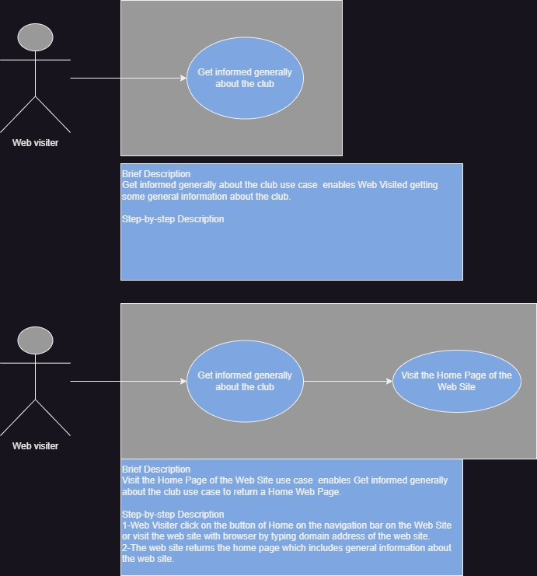

### Find Out Services about the club Use Case UML Diagram

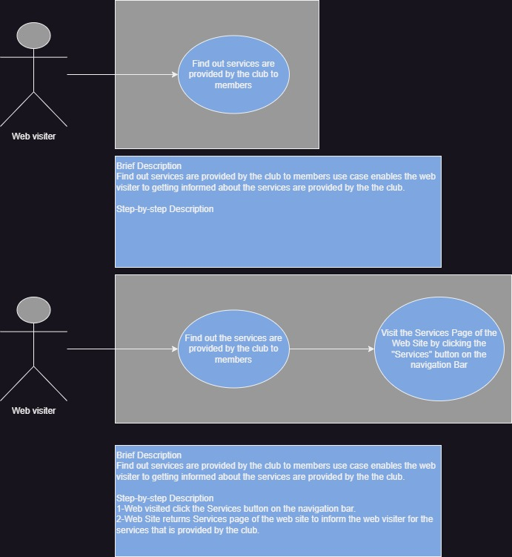

### Get informed about the club more Use Case UML Diagram

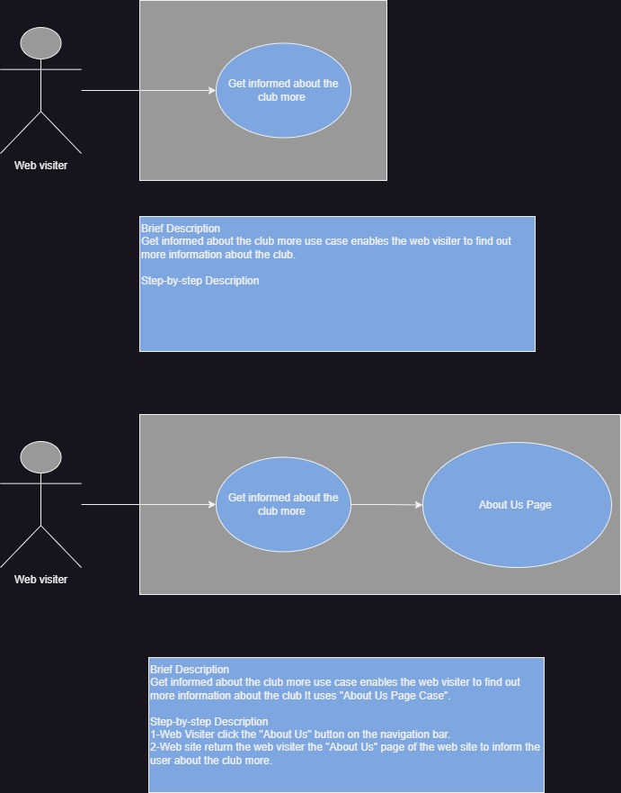

### Contact with the Club Coordinators Use Case UML Diagrammetin, ekran görüntüsü, tasarım, diyagram içeren bir resim Açıklama otomatik olarak oluşturuldu

### All Use Case UML Diagrams in One UML Diagrammetin, ekran görüntüsü, diyagram, daire içeren bir resim Açıklama otomatik olarak oluşturuldu

I’ve analyzed 2 web pages online. Both of them are tennis clubs from Netherlands which is my dram country to live in.

First Web Site: https://amstelpark.nl

Second Web Site: <https://sportcentrumdekloek.nl>

I’ve look these web sites and see how responsive they are. So my web sites must be like that.

I’ve started to design my pages like that in the below.

## DESIGN PHASE

In this phase the structure of my web site must be defined. The elements and their attributes and their values could be defined.

### HOME PAGE DESİGN

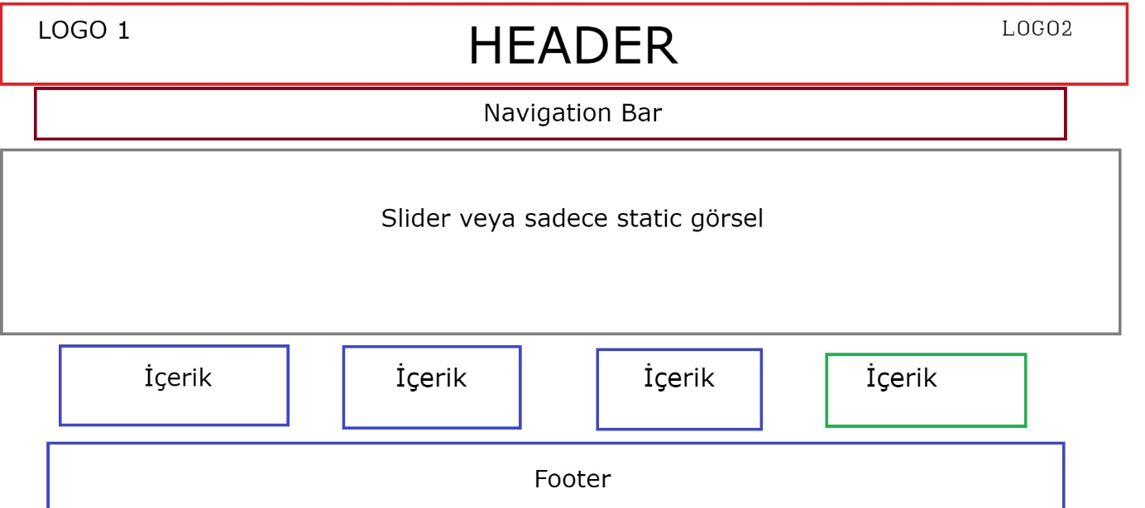

There will be no margin between header and the body of the web page.

Also, there will be no margin between navigation bar and header.

Slider will slide images automatically in each 5 seconds and users will be able to slide previous images or next images by clicking buttons.

Footer will include some basic information about the club and web page.

Header,Logo1 and Logo2 will be flexible.

Navigation Bar will be detailed in the further of the report.

### ABOUT US PAGE DESIGN

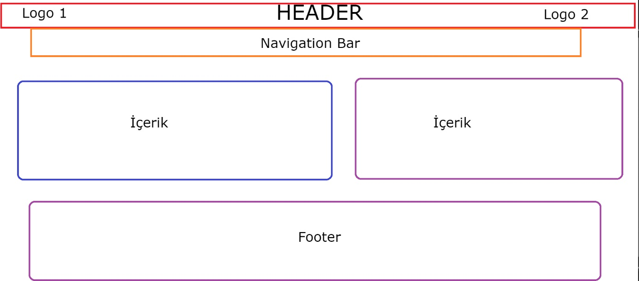

There will be no margin between header and the body of the web page.

Also, there will be no margin between navigation bar and header.

One of the content will be a logo. One of the content will be content which includes more information about the club.

### SERVICES PAGE DESIGNPAGE DESIGN

There will be no margin between header and the body of the web page.

Also, there will be no margin between navigation bar and header.

One of the content will be a logo or image of the club. One of the content will be content which includes information about the services which are provided by the club.

### CONTACT US PAGE DESIGN

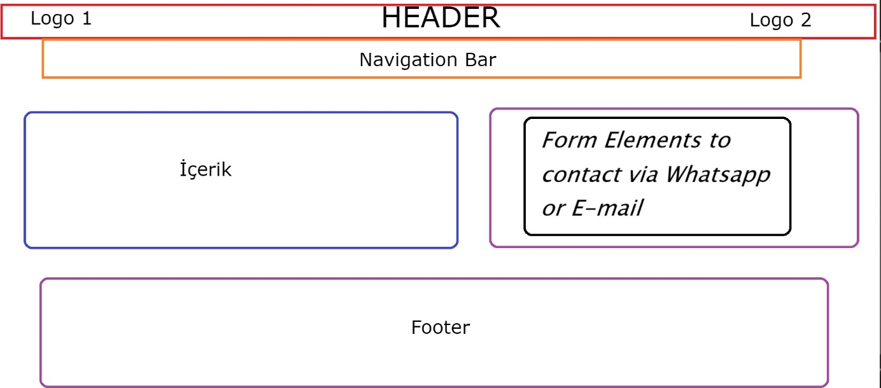

There will be no margin between header and the body of the web page.

Also, there will be no margin between navigation bar and header.

Left Content will be an image of the club or logo.

**There will be Form Elements to contact via Whatsapp or E-mail next to Content element.**

Form elements will take inputs from the users. They will be processed then they will be send to club coordinators. The value of “**method”** proportiy of the <form> tag will be **“GET” to** make the web site more **secure.**

### DETAILED <HEADER> ELEMENT



**<header>** will be **container** of logo1,h1,logo2.

<H1> will be name of the club.

**<header>** will be **flexible** I mean **display** property of the header will be **flex.** This allow the web site be **responsive** when the size of the screen is changed.

### DETAILED <NAV> ELEMENT



First figure

**<NAV>** will be **container** of HOME, ABOUT US, SERVICES, CONTACT list items. They will be clickable. They will be in an **ancho**r tag with **href** attribute.

**<nav>** will be **flexible** I mean **display** property of the header will be **flex.** This allow the web site be **responsive** when the size of the screen is changed.

When the size of the screen is really small like mobile phones. Elements will be look like that in the below it’s figured.

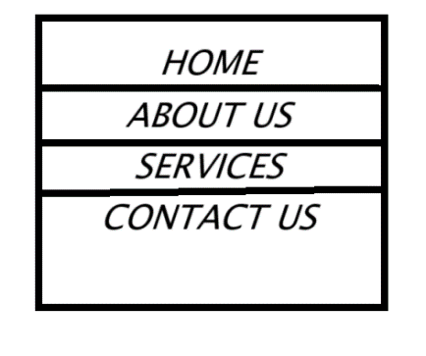

**Second Figure**

In order to do that I need to use **media queries**.

When the max-width of the screen is **600px** The nav bar will be like second figure.

## IMPLEMENTATION PHASE

I have not decided plenty of things in the design phase especially colors. I will decide while I am implementing the structure of designing. In short while I am coding I will decide or I will go back to design phase to change the design.

### <HEADER> ELEMENT OUTPUT



### <NAV> ELEMENT OUTPUT



When I’ve hover elements of the navbar the background color will be change little bit lighter like this in the below.



When I’ve change the size of the screen below the 600px the navbar will be like this in the below.



### <FOOTER> ELEMENT OUTPUT

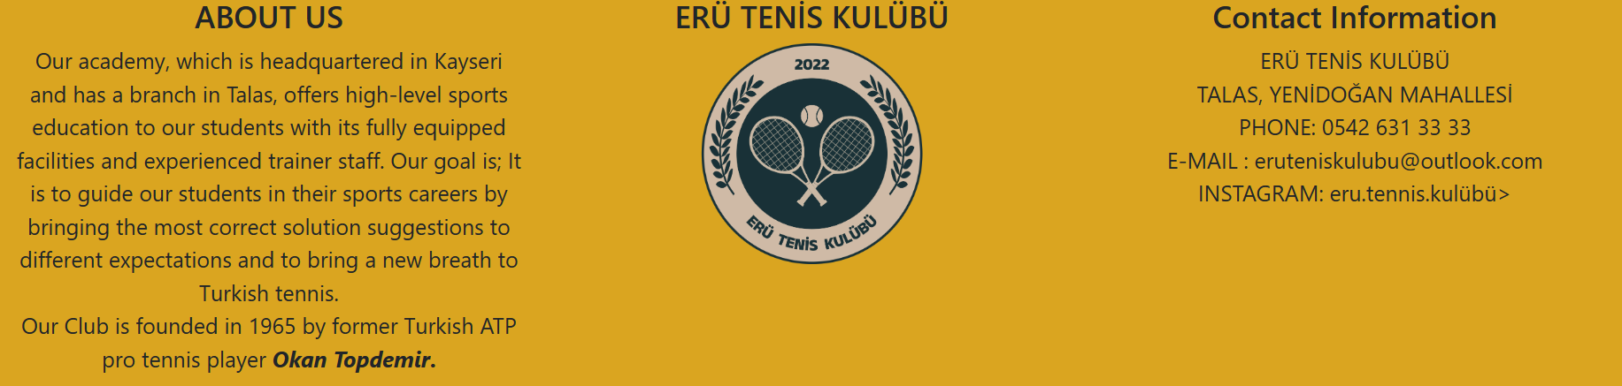

### HOME PAGE OUTPUT

#### First part of the Home Page

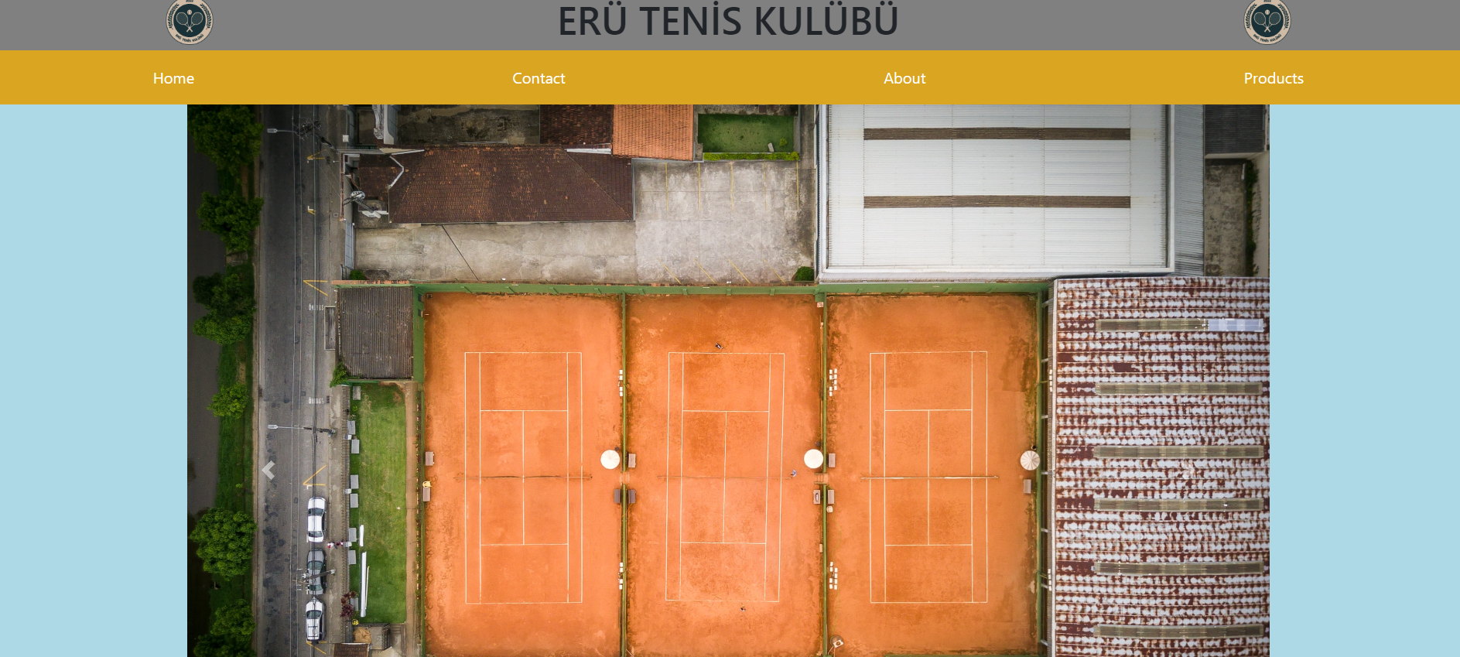

#### SECOND PART OF HOME PAGE

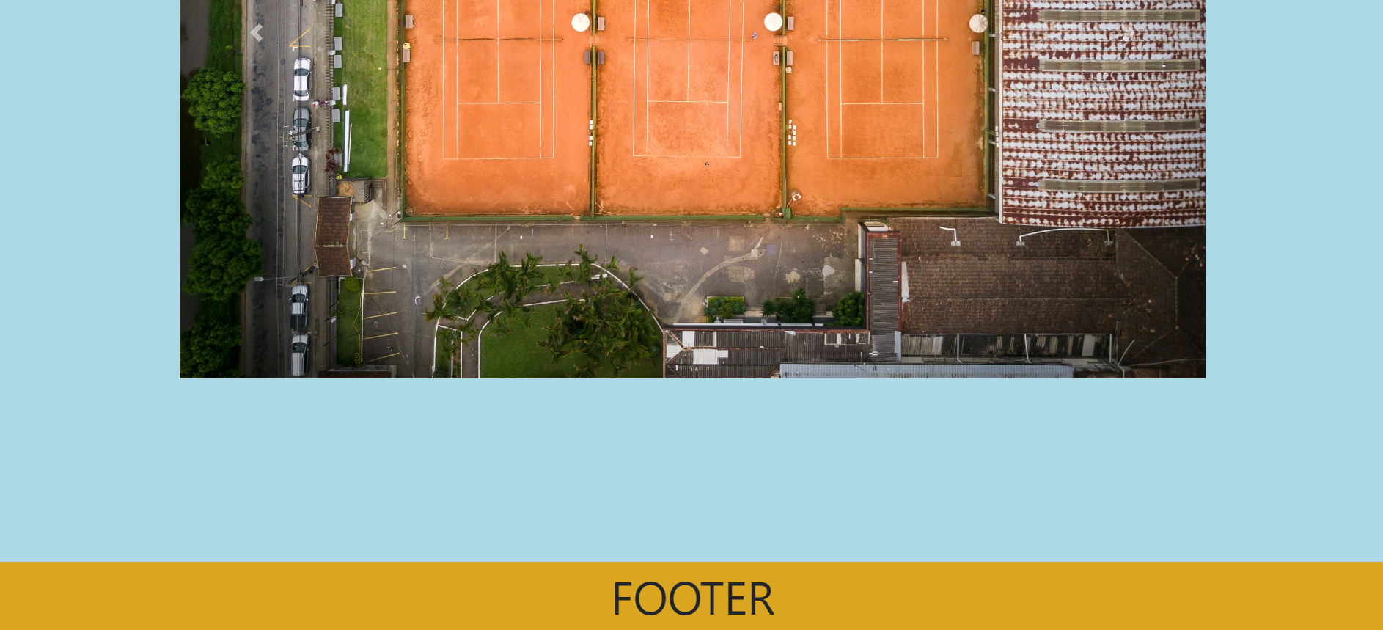

### CONTACT PAGE OUTPUT

#### First Part of the Contact Page

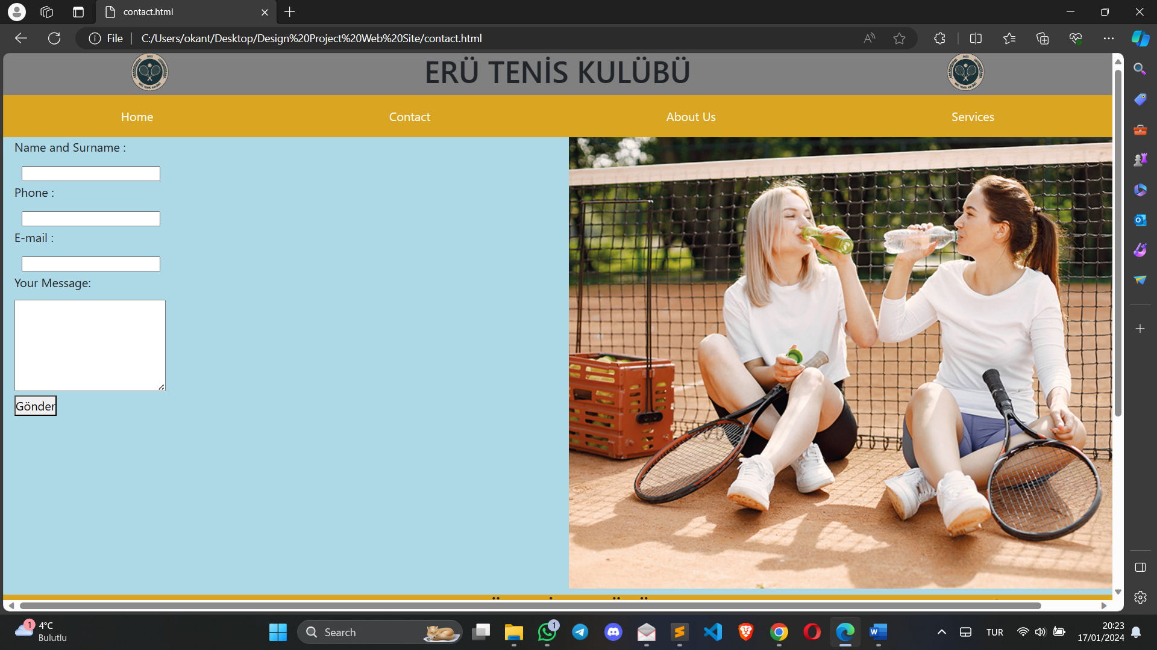

#### Second Part of the Contact Page

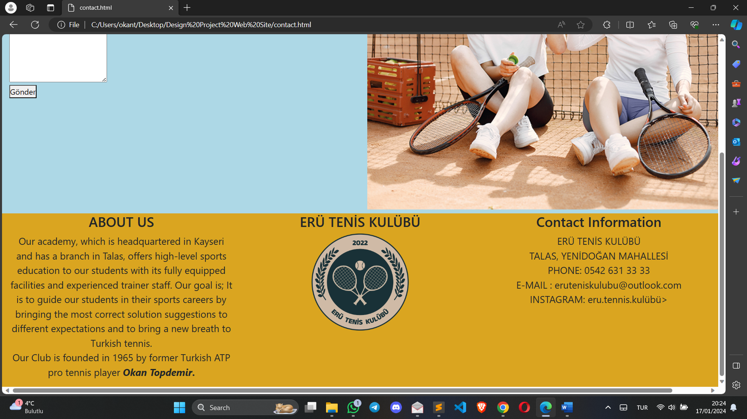

### ABOUT US OUTPUT

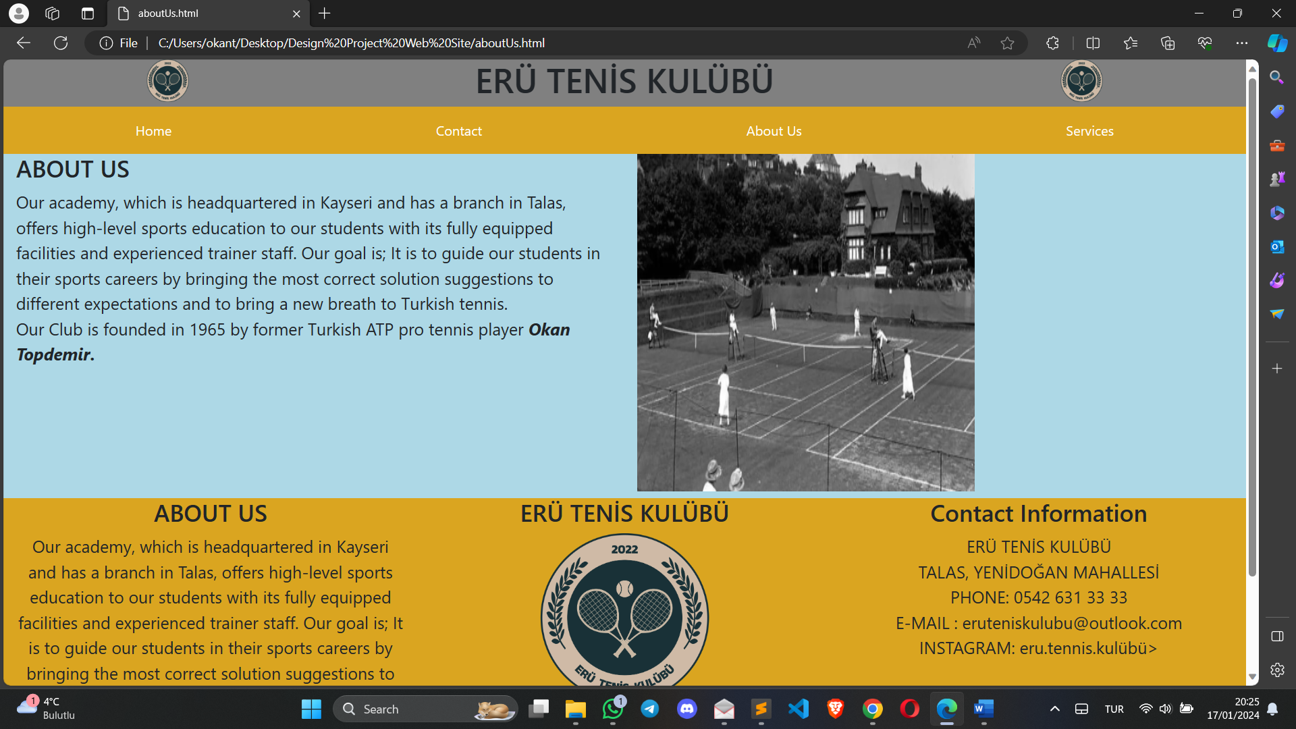

### SERVICES PAGE OUTPUT

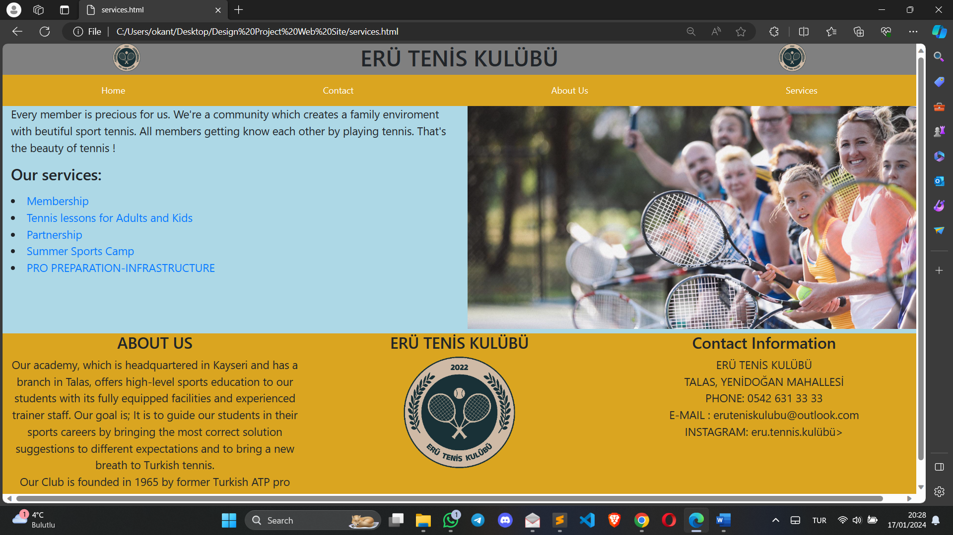

### 1st part of the Services (Membership Anchor Link)

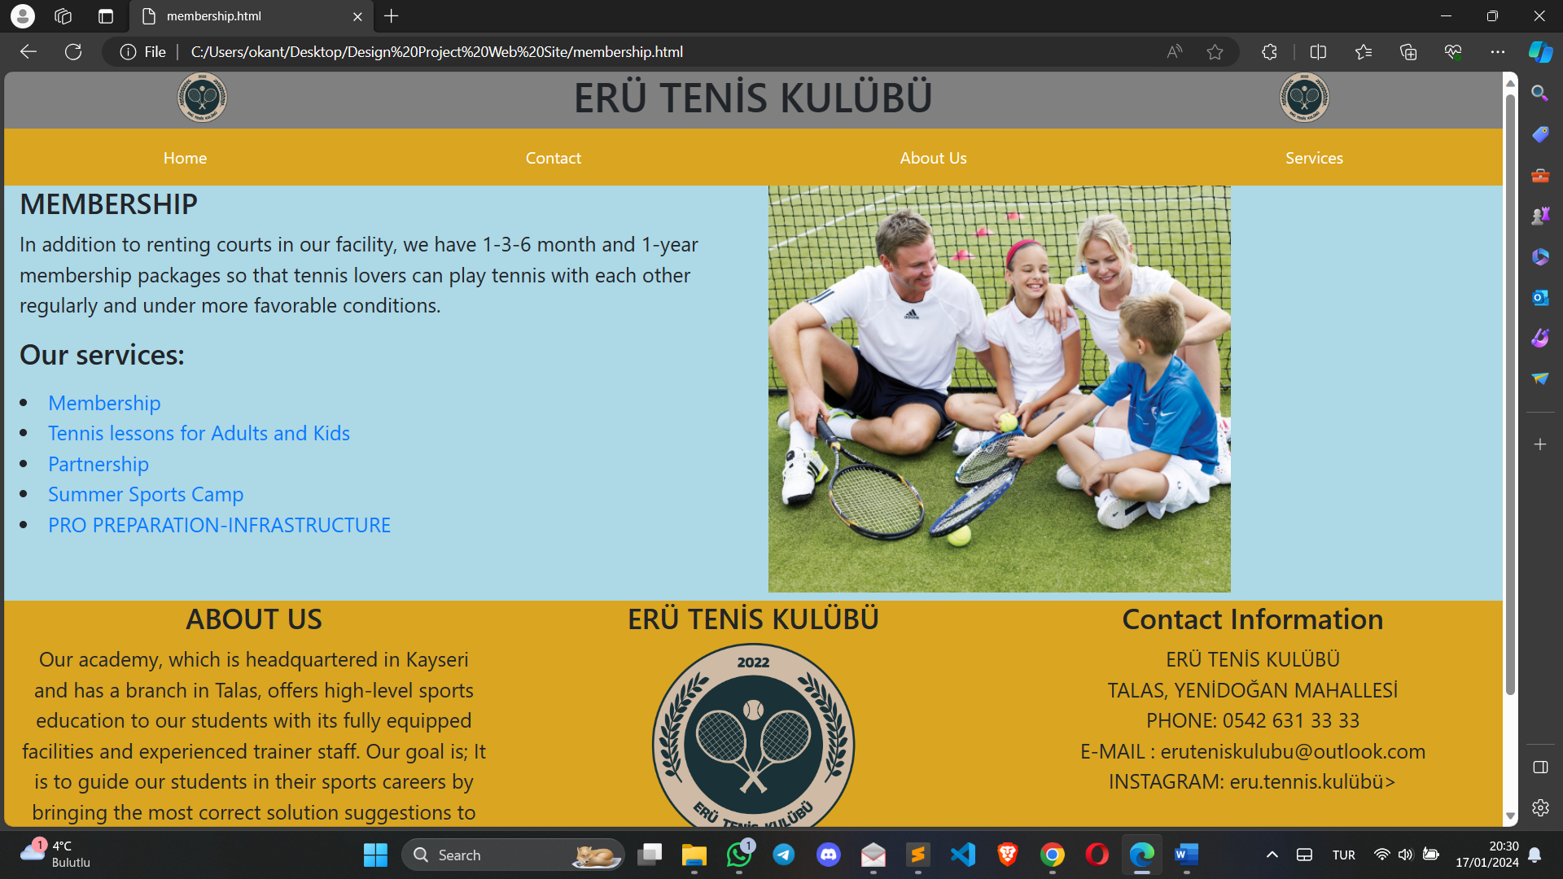

### 2nd part of the Services (Tennis Lessons Anchor Link)

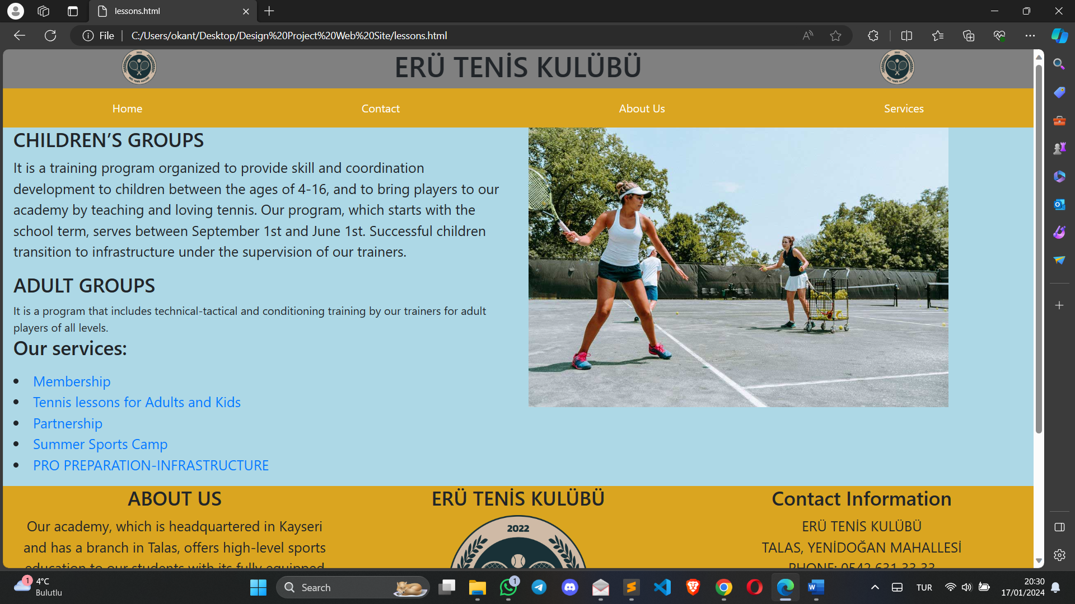

### 3rd part of the Services (Partnership Anchor Link)

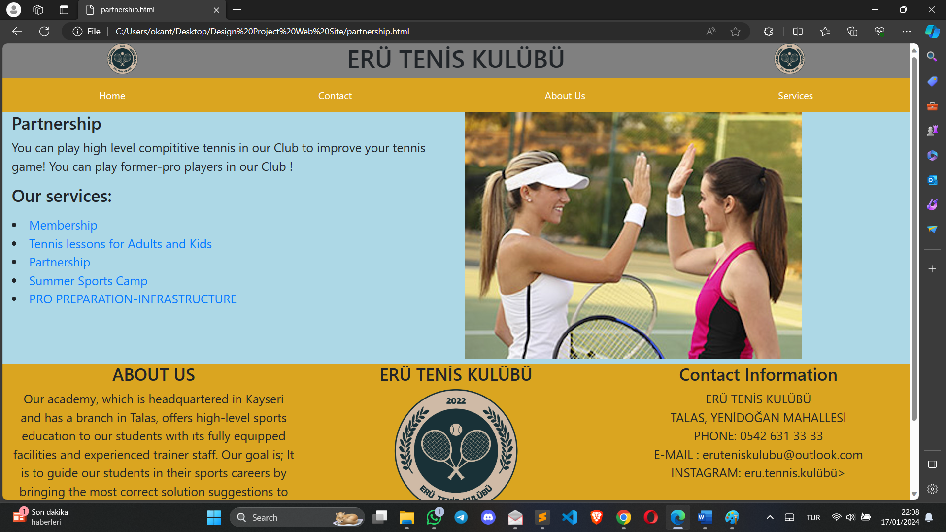

### 4thpart of the Services (Summer Sports Camp Anchor Link)

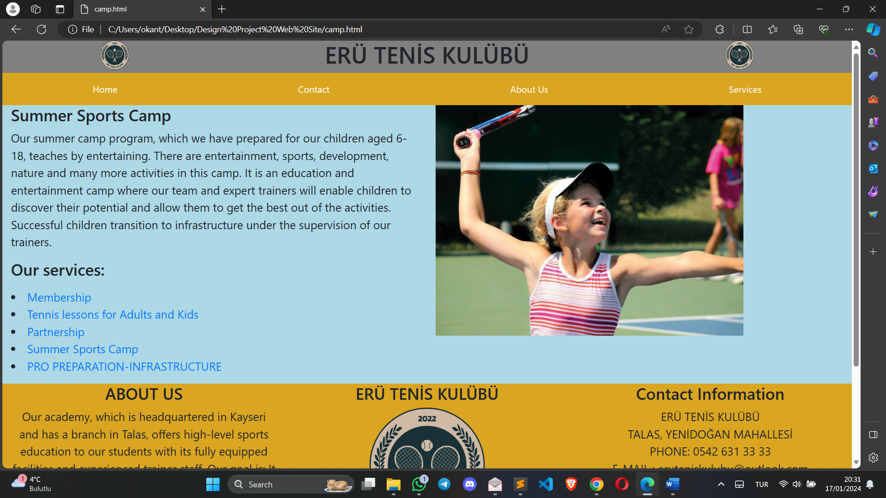

### 5th part of the Services (Pro Preparation-Infrastructure Anchor Link)

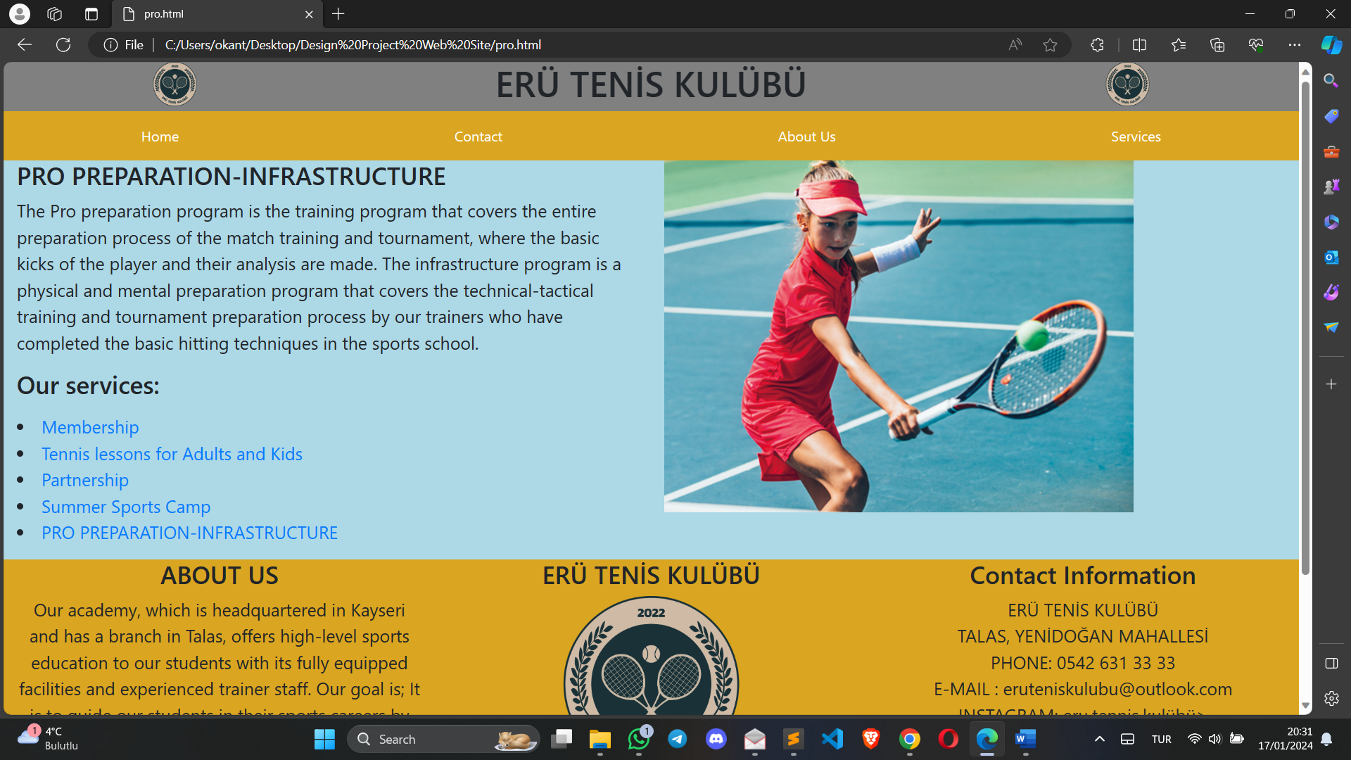

## SUMMARY

I’ve implemented the design of the project successfully. I’ve done test activities for my project in the implementation phase more than in other phases.

Every part of the project is working correctly. I can route through the pages by clicking anchor tags.

It’s a kind of static web page which doesn’t have very much functionality. Only functional part of the web site is contact page where we can send messages via e-mail to contact with a club stuff to get more information or being part of the club.

Thank you for reading my whole **Final-Report** of my **Tennis Web Site Project😊**